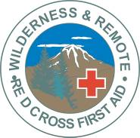

**REGISTRATION Confirmation**

**Please send this form and credit card info, cheque or money order deposit of $75.00 or course fee to:**

**Doyle Adventure & Safety, 28 Virginia Ave., Dartmouth, N.S., B2W 2Z7**

**Name on Card:**

**Credit Card # Expiry:**

**\*\* please indicate if you want to pay the full amount or just the deposit**

**\*\* deposit non-refundable 30 days before program \*\***